**Experiment No. 1.2**

**Student Name: Rishav Kumar UID: 22MCC20039**

**Branch: MCA - CCD Section/Group: MCD-1/ Grp A**

**Semester: III Date of Performance: 24th Aug 23**

**Subject Name: DevOps Process Automation Lab Subject Code: 22CAP-745**

1. **Aim/Overview of the practical:**

* Create a new file named UID_Name.txt in your local repo and add some content in the file and push it to the remote repository.
* Manage to create a two new branches using Git. Two branches must be named as your UID and Name respectively.
* Now, after creating branches, UID_Name.txt file must be available in Branch UID. Make some changes in the file present in Branch UID.
* After this, come back to your Master branch and merge the file with Branch UID file. If you face any conflicts, remove it.
* Create a new file named as Name.txt in Branch Name. Now try to merge it with Branch UID file. Will it be merged or not? show after implementing it.

**Code for practical:**

* Open command prompt or git bash.
* Create a folder using command ***mkdir 22MCC20039***
* Change directory using ***cd 22MCC20039***
* Add remote repo using command ***git remote add origin https://github.com/Rishav518/22MCC20039.git***
* Pull main repo using ***git pull origin main***
* Add a new file push it to repo after adding to git using

***notepad secondfile.py***

***git add secondfile.py***

***git commit -m "Second file added"***

* Create a new branch using ***git branch master***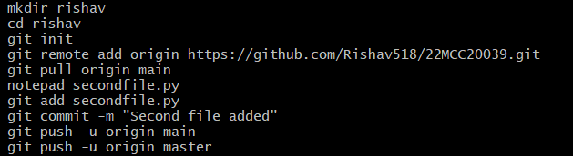
* Go to to other branch use command, ***git checkout [branchName]***
* Push main and master branches

***git push -u origin main***

***git push -u origin master***

* Now, merge branches using ***git merge master***
* Now pull repo using pull command ***git pull origin master***
* You can view the changes in Github.com

**************************************** **THE END** ***********************************************